Object Methods

Object.assign()

The **Object.assign()** method copies all [enumerable](https://devdocs.io/javascript/global_objects/object/propertyisenumerable) [own properties](https://devdocs.io/javascript/global_objects/object/hasown) from one or more source objects to a target object. It returns the modified target object.

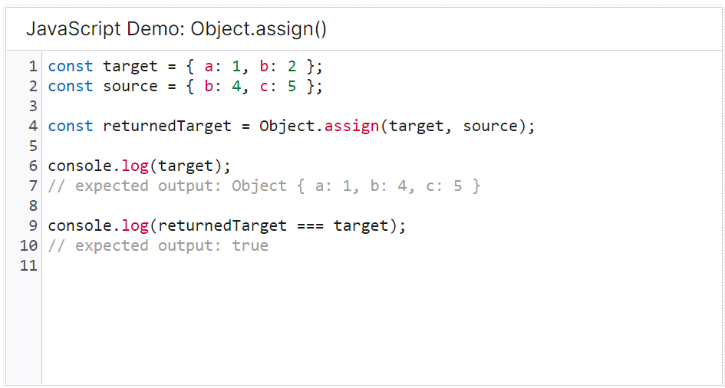

Object.create()

The **Object.create()** method creates a new object, using an existing object as the prototype of the newly created object.

Object.entries()

The **Object.entries()** method returns an array of a given object's own enumerable string-keyed property [key, value] pairs. This is the same as iterating with a [for...in](https://devdocs.io/javascript/statements/for...in) loop, except that a for...in loop enumerates properties in the prototype chain as well.

Object.freeze()

The **Object.freeze()** method *freezes* an object. Freezing an object [prevents extensions](https://devdocs.io/javascript/global_objects/object/preventextensions) and makes existing properties non-writable and non-configurable. A frozen object can no longer be changed: new properties cannot be added, existing properties cannot be removed, their enumerability, configurability, writability, or value cannot be changed, and the object's prototype cannot be re-assigned. freeze() returns the same object that was passed in.

Object.hasOwn()

**The Object.hasOwn()** static method returns true if the specified object has the indicated property as its *own* property. If the property is inherited, or does not exist, the method returns false.

Object.hasOwnProperty()

The **hasOwnProperty()** method returns a boolean indicating whether the object has the specified property as its own property (as opposed to inheriting it).

Object.keys()

The **Object.keys()** method returns an array of a given object's own enumerable property **names**, iterated in the same order that a normal loop would.

Object.isExtensible()

The **Object.isExtensible()** method determines if an object is extensible (whether it can have new properties added to it).

Object.preventExtensions()

The **Object.preventExtensions()** method prevents new properties from ever being added to an object (i.e. prevents future extensions to the object). It also prevents the object's prototype from being re-assigned.

Object.prototype.propertyIsEnumerable()

The **propertyIsEnumerable()** method returns a Boolean indicating whether the specified property is enumerable and is the object's own property.

